AIST - AIST - Reverse Settlement of AUC

Functionality
The asset under construction can be either a normal asset record, or a master record with line item management. Before an asset can be “settled” to another asset / object, a distribution rule is assigned to the asset master record. This transaction can be run in test mode and can also be reversed.

Scenario
The transfer from the asset under construction to completed fixed assets can be handled in one of two ways:
Line item settlement of an asset under construction that has line item management.
AUC reversal reverse the settlement made to the assigned asset and re-assigns all cost to the original AUC.

Requirements
An AUC settlement previously carried out on an asset master record should exist.

Menu Path | SAP menu → Accounting → Financial Accounting → Posting → Reverse Document → AIST - Capitalize Asset u. Const.
Transaction Code | AIST

1. Double Click on AIST - Capitalize Asset u. Const.

Reversal of Settlement of AuC: Initial Screen

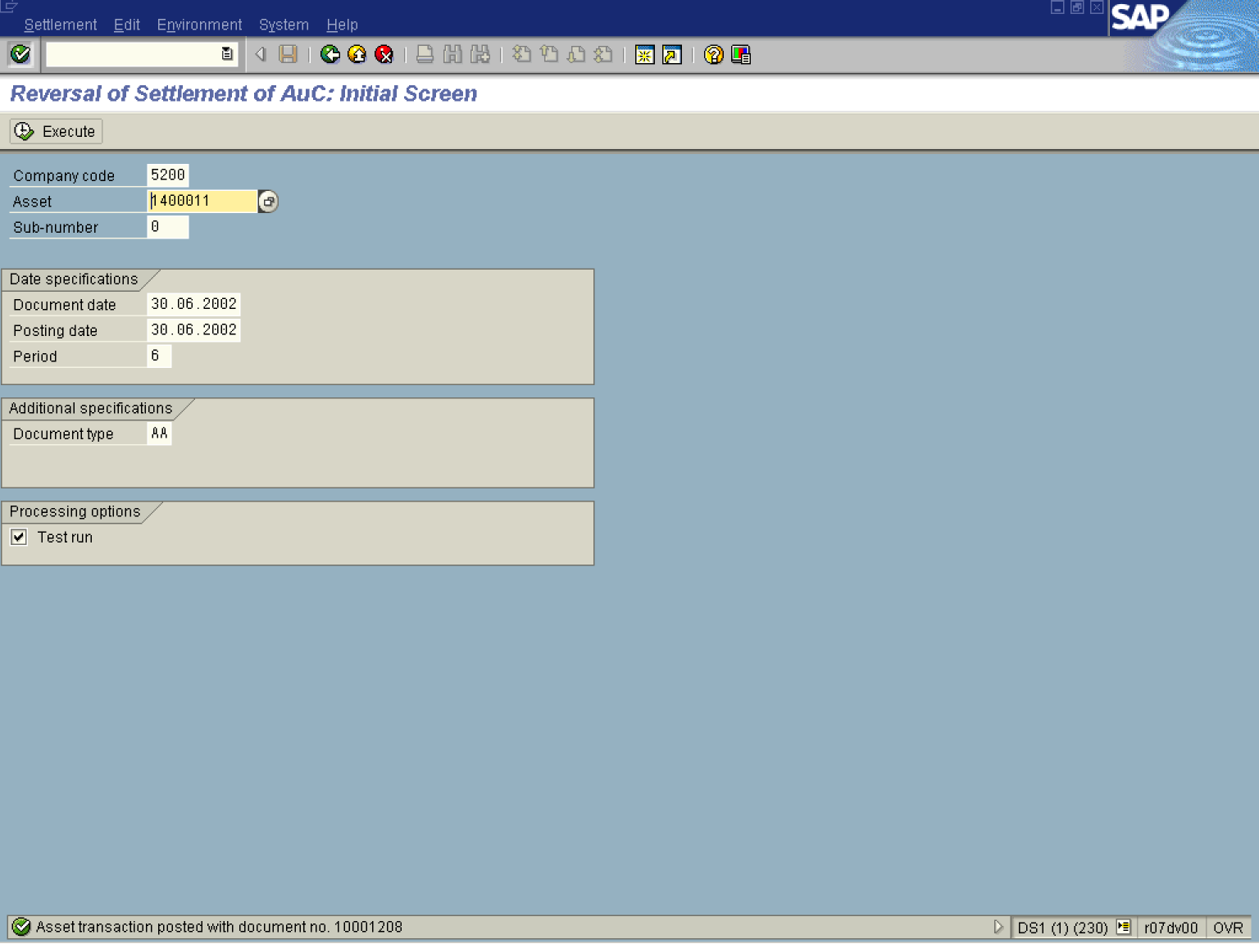
2. Update the following fields:

Field Name | Field Description | Values
Asset | This is the number which, together with the asset sub-number, identifies a fixed asset in Asset Accounting. | Example: 1400011
Document type | Code identifying the method that the system uses to process the transaction | Example: AA
3. Click the Enter button.
4. Click Execute .

Reversal of Settlement of AuC: Initial Screen

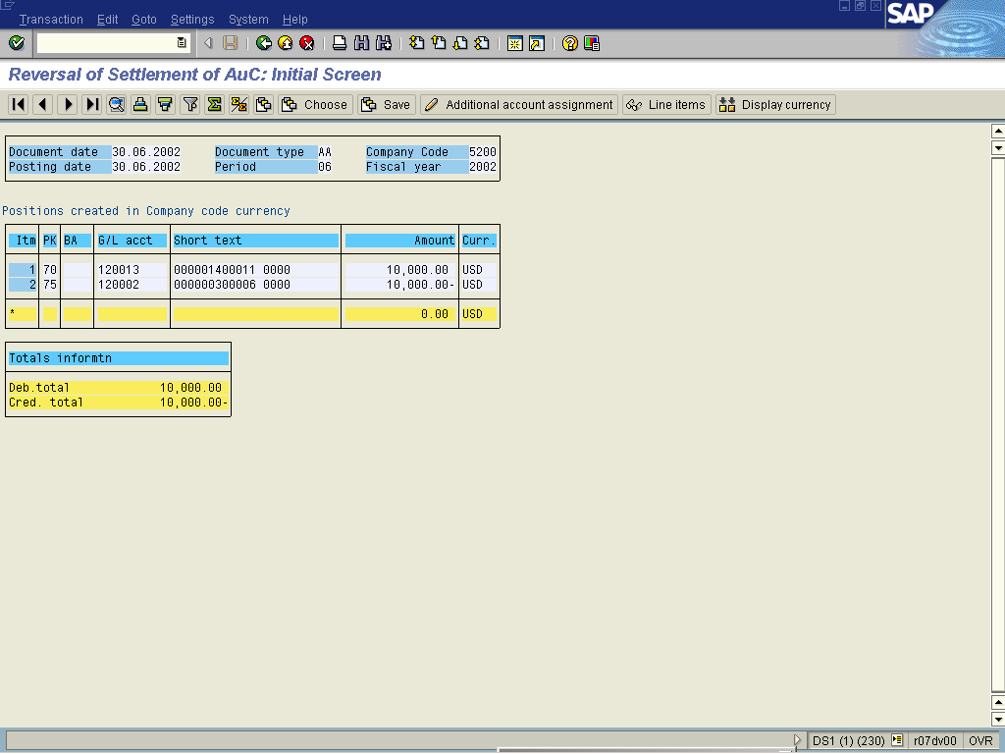
Note: The system displays an overview of the transaction that will be posted.
5. Click Back to run the transaction in productive mode.

Reversal of Settlement of AuC: Initial Screen

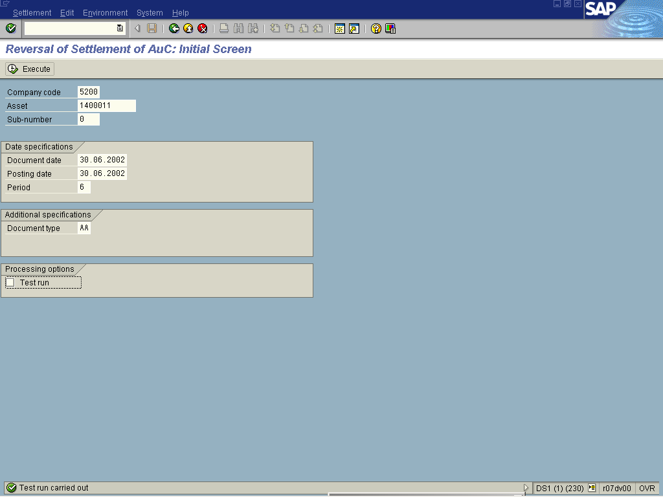

6. Click <checkbox> Test run .
Note: Processing type for programs which change data:
When the flag is active: the program is executed normally, all checks in the program are performed, their results are output in various forms (as single message, as a collection of messages, or as a log), but existing data are not changed.
When the flag is inactive: the program is executed normally. All data changes (change, delete, insert new data records) are made in the database (real run).
7. Click Execute .
Reversal of Settlement of AuC: Initial Screen

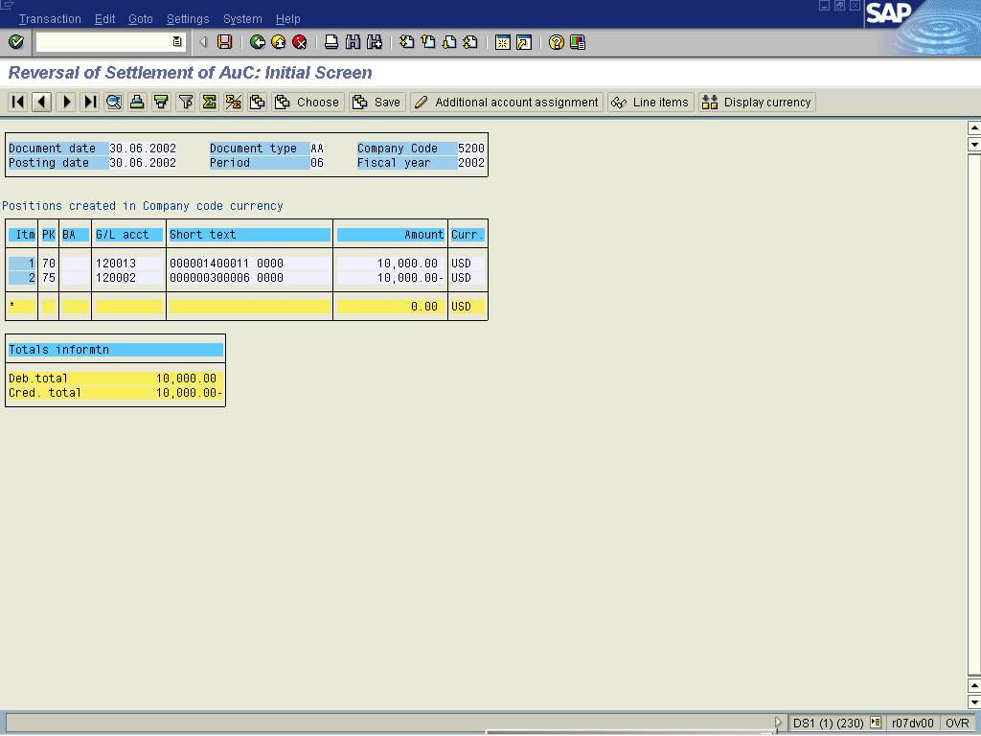
8. Click the Save button.

Reversal of Settlement of AuC: Initial Screen

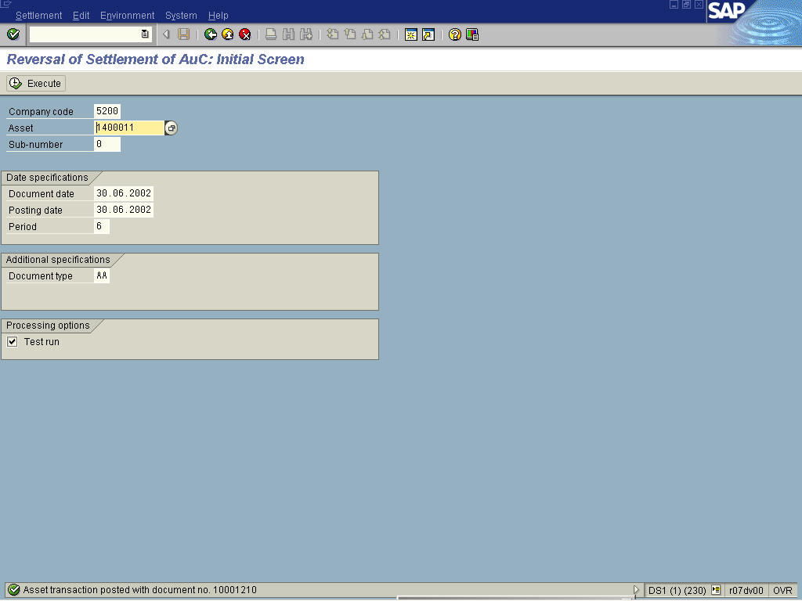

9. The message bar displays “Asset transaction posted with document number XXXXXX”

